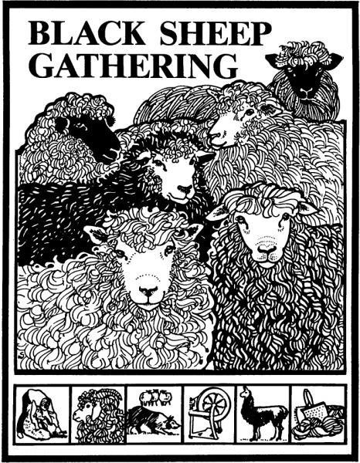
2024 BSG Workshop Proposal Form
The deadline for applications is October 20

Mary Reynolds
172 Oakleigh Lane Unit 712 #26
Eugene OR 97404 Email to:
blacksheepworkshops@gmail.com
Other team members:
Connie Paulsen (Curriculum)(Onsite Logistics)
blacksheepworkshops@gmail.com
Mila Butler (Registrar)
Reg.blacksheep@gmail.com

Workshop Description
Please complete and/or edit this entire form. The class information and instructor bio will be used in the Black Sheep Newsletter, posted on the website, and for other publicity and outreach efforts. It will also help us to ensure that the classes run smoothly. Please use one form for each workshop.

Instructor’s name: Phones:

Address: Email:

Workshop title: Class Length: 3 hr 6 hr

Description: Level of student experience required:

Instructor biography (100 words or less):

List of materials and/or advance preparation required of students:

Space & equipment requirements: (tables, chairs, outlets, overhead projector, slide projector, blackboard, etc.) Be very specific.

Materials fee: What materials are provided for students (covered by materials fee):

Maximum number of students: Minimum number of students:

Special instructions:

