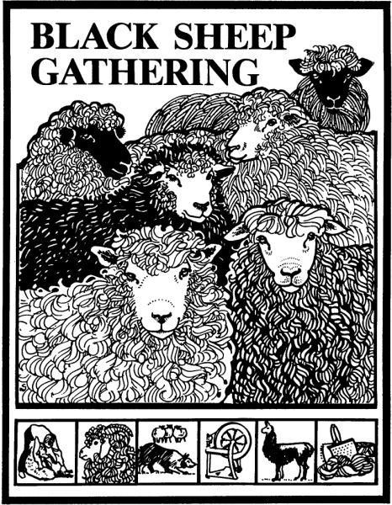**2026 BSG Workshop Proposal Form**

The deadline for applications is October 20th, 2025

**Email fillable form and attached pictures to**

[blacksheepworkshops@gmail.com](mailto:blacksheepworkshops@gmail.com)

Team members:

**Mila Butler:** (Registrar)

**Mary Reynolds:**(Contracts)

**Connie Paulson:** (Curriculum)(Onsite Logistics)

**Just a heads up- This form has changed!**

Please edit or fill out the entire form. You can put up to 5 proposals on one form. **You can now attach photos via email** along with this form. A teacher photo and a photo of your craft would be appreciated. We want to get to know you and promote your skillset to students through photos. Bios and descriptions will be posted on BSG catalog and website.

# Instructor’s name:

Mailing Address**:**

**Email:** **Phone:**

**Instructor biography (300 characters or less):**

**Links to social media or personal websites of affiliated businesses:**

**May we share these sites on our social media pages?**

**Areas of focus that you currently teach in (**weaving, spinning, felting, dyeing, basketry, mending, etc!):

**Scheduling info:**

Please write any times during the weekend of June 26th-28th that you have schedule limitations:

**Submit proposals on following pages**

**Proposal 1**

**Instructor Name:**

# Workshop title:

# Class Length: 3 hr 6 hr 12 hr

# **Level of student experience required:** Beginner Intermediate Advanced

**Class Description:**

**List of materials students bring and/or advance preparation required of students:**

**Space & equipment requirements:** (tables, chairs, outlets, overhead projector, whiteboard etc.) Be very specific.

**Materials fee** (collected by BSG):

**What materials are covered by materials fee:**

Minimum number of students: Maximum number of students:

# Notes or special instructions for BSG set-up team:

**Proposal 2**

**Instructor Name:**

# Workshop title:

# Class Length: 3 hr 6 hr 12 hr

# **Level of student experience required:** Beginner Intermediate Advanced

**Class Description:**

**List of materials students bring and/or advance preparation required of students:**

**Space & equipment requirements:** (tables, chairs, outlets, overhead projector, whiteboard etc.) Be very specific.

**Materials fee** (collected by BSG):

**What materials are covered by materials fee:**

Minimum number of students: Maximum number of students:

# Notes or special instructions for BSG set-up team:

**Proposal 3**

**Instructor Name:**

# Workshop title:

# Class Length: 3 hr 6 hr 12 hr

# **Level of student experience required:** Beginner Intermediate Advanced

**Class Description:**

**List of materials students bring and/or advance preparation required of students:**

**Space & equipment requirements:** (tables, chairs, outlets, overhead projector, whiteboard etc.) Be very specific.

**Materials fee** (collected by BSG):

**What materials are covered by materials fee:**

Minimum number of students: Maximum number of students:

# Notes or special instructions for BSG set-up team:

**Proposal 4**

**Instructor Name:**

# Workshop title:

# Class Length: 3 hr 6 hr 12 hr

# **Level of student experience required:** Beginner Intermediate Advanced

**Class Description:**

**List of materials students bring and/or advance preparation required of students:**

**Space & equipment requirements:** (tables, chairs, outlets, overhead projector, whiteboard etc.) Be very specific.

**Materials fee** (collected by BSG):

**What materials are covered by materials fee:**

Minimum number of students: Maximum number of students:

# Notes or special instructions for BSG set-up team:

**Proposal 5**

**Instructor Name:**

# Workshop title:

# Class Length: 3 hr 6 hr 12 hr

# **Level of student experience required:** Beginner Intermediate Advanced

**Class Description:**

**List of materials students bring and/or advance preparation required of students:**

**Space & equipment requirements:** (tables, chairs, outlets, overhead projector, whiteboard etc.) Be very specific.

**Materials fee** (collected by BSG):

**What materials are covered by materials fee:**

Minimum number of students: Maximum number of students:

# Notes or special instructions for BSG set-up team: